PsychoSocial Rehabilitation (PSR)
Course Information

Description:

Psychosocial rehab (PSR) encompasses community-based or clinic-based but community-focused services designed to assist adults in strengthening or regaining skills designed to help them achieve their self-determined rehabilitation goals in living, working, educational or social environments and the development of environmental supports necessary to thrive in the community with the least amount of professional intervention possible.

Delivery of Psychosocial Rehabilitation Guidelines have established the following basic principles to guide the delivery of PSR services:

- Adults who participate in psychosocial rehabilitation have chosen to do so and have been assessed to be ready to participate and set self-determined rehabilitation goals.

- The PSR plan is individualized and tailored to the specific adult’s goals, barriers, and strengths.

- All PSR activities are designed to show progressive steps towards the targeted goals.

- Motivational interviewing techniques may be used to establish ‘connection’ between the PSR treating provider and the adult.

- All PSR is based on the development and maintenance of specific skills and supports to meet the specific self-determined rehab goals.

- All PSR skills training meets the definition of a ‘skill’ and is done using a progressive skills training plan. Only specifically needed skills are taught (i.e. not everyone needs to make a menu, read labels, and cook to live independently).

- PSR is done in groups when the individual can clearly benefit from the skill set included in the class and the shared learning experience the class offers. (Organized Curriculum of skills set)

- PSR is done approximating or using ‘real life’ conditions where possible.

- PSR services are broken into achievable actions to facilitate success and successive improvement.

PsychSocial Rehabilitative Program (PSR)
Presented by

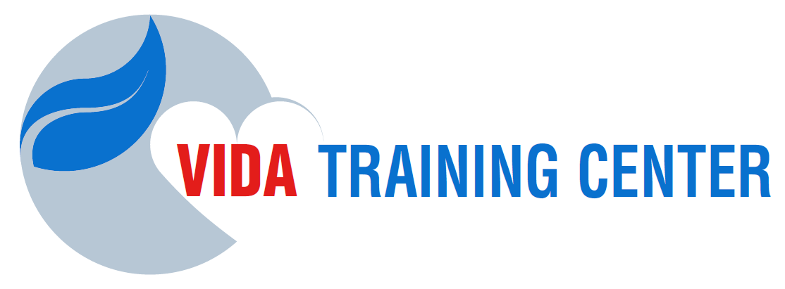

Note to students:
All online modules and exams to be completed.
The time frame for completing your 75 hours is, from your registration, minimum 30 days maximum 90 days.
You can begin the class at any time and participate in our monthly webinars.
You are responsible for your own deadlines and registrations with the DCF, FCB and Medicaid.

Regardless of when you begin our courses,
PLEASE PLAN TO JOIN OUR WEBINARS:
Dates to be announced monthly.
.

Program Contains:

- CBHT - Certification and all In-Services Required by FCB and DCF $550
- FARS / CFARS
- Multicultural Counseling
- Mental Health & Substance Abuse 8 hours Curriculum
- Marchman Act / Baker Act
- PSR – In Services Package $55
- Guidance in opening online accounts for all State Agencies and Board.
- Level II – Background Check $90

This program offers the training requirements for the Florida Certification Board application as a
Certified Behavioral Health Technician (CBHT) and with all Medicaid / AHCA requirements

If you have some of these trainings completed already please call for a customize quote.

Vida Training Center, LLC
https://vidatraining.center/en
786-316-7106

